Directions: Using the article titled How Totem Poles Work, complete each question about the history of totem poles. Be sure to include specific details, if necessary.

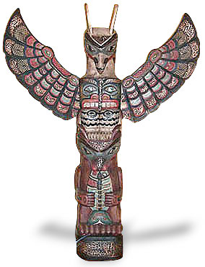

- A totem pole is considered to be a representation of a ____________________________.

- Circle the best answer:
Totem poles take:
a day a week a month multiple months to complete.

- Authentic totem poles are normally made from ______ or _______ ____________.

- The traditional colors of totem poles include:
____________

____________

____________

____________

____________

- It is believed that totem poles last up to ________________.

- There are three things that must be present in order for a totem pole to be considered authentic and they are the following:
_______________________________________________________
_______________________________________________________
_______________________________________________________
- A potlatch is ______________________________________________________________________________________________________________

- The three kingdoms of which the American Indian symbols come from are
______________

______________

______________

- Explain the interpretation of the following symbols:

Eagle: __________________________________________________________

Thunderbird: ____________________________________________________________
Bear:
____________________________________________________________

Owl:
____________________________________________________________

Wolf:
____________________________________________________________

Raven:
____________________________________________________________

Frog:
____________________________________________________________

- There are various types of totem poles, define each of the following.
Entryway totem poles:
________________________________________________________________________________________________________________________

Ridicule totem poles:
________________________________________________________________________________________________________________________

Mortuary totem poles:
________________________________________________________________________________________________________________________

